Jacob Dunn

3/21/23

Lab5 PreLab

The board setup is shown below, with the GY-521. The four pins from the lab handout were connected, with Vcc on 3.3V

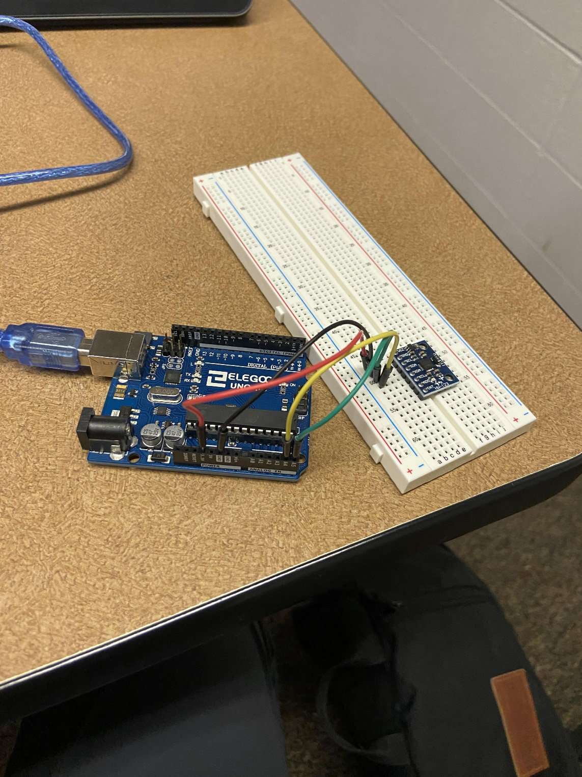

Below is the code that was commented out in order to have the serial monitor print only the values I wanted

Below is the code I added under readMpuData to convert the values into terms of g

Below is the output of the serial monitor with the modified code. The module was stationary so no acceleration on x or y, and z is 1 due to acceleration from earth’s gravity

Below is the table required to be filled out and the formula that the calculations were based on

Acceleration (g) = Raw Value / 16384

|  |  |
| --- | --- |
| **Axis** | **Raw Value** |
| X+ (X = -1g) | -16384 |
| X- (X = +1g) | 16384 |
| Y+ (Y = -1g) | -16384 |
| Y- (Y = +1g) | 16384 |
| Z+ (Z = -1g) | -16384 |
| Z- (Z = +1g) | 16384 |